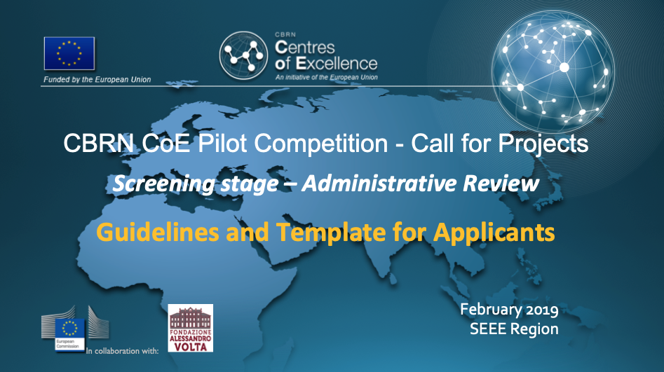

This document sets out the guidelines for individuals and teams that wish to take part in the Pilot Competition 2019 of the European Union’s CBRN Centres of Excellence Initiative in the South-Eastern and Eastern Europe (SEEE) Region.
The concept of this Pilot Competition as well as eligibility criteria, the application and selection processes, and the nature of the awards are explained in a separate document: a brochure called “From networking to innovative capacity building”.
Further information for potential applicants on the pilot competition is contained in the “General Information for Applicants” circular that is being circulated alongside these guidelines.
All documents are also available from the National Focal Points (NFPs) of the SEEE countries, and can be downloaded from the Pilot Competition Facebook Page.

Guidelines
Participants can submit their competition entries by completing an application form via the Pilot Competition Web Portal. The Portal will be open for receiving Concept Note (Slide deck PE) from 27 March to 01 April 2019. The address of the Web Portal will be circulated to participants directly by e-mail.
Please read this document carefully while you are preparing for submitting your application.
The application form on the Web Portal uses the same template as the one shown on the following page. Participants are encouraged to prepare their application entries in advance, as this may require some additional research or may require asking for clarifications.
Before completing the application forms, please take note of the following points:
- Completing the application forms will require a certain amount of time as applicants are expected to research the terminology used in the questions posed, and to demonstrate an understanding thereof.
- Completing the application form on the Web Portal signals a commitment by the applicants to follow through with the entire Pilot Competition programme, should they be selected as finalists (see also the General Information for Applicants circular).
- The application forms have been designed in the form of three slides (a “pitch deck”). These forms:
  - Should be filled in jointly by the project team (except for individual competitors)
  - Will allow the competition organisers’ to evaluate the strengths and weaknesses of the different applicants (see also the General Information for Applicants circular)
  - Will be used by the peer reviewers to score the pilot competition entries, allow a ranking and the selection of the finalists.
On the following page, the structure and required content of the three slides are explained. Note that the number of words is limited for each data entry field.
Slide 1 – The Context

1. Explain the “pain point” that your prospective customers are experiencing and that your solution will resolve (to learn more about pain points, see for example https://www.wordstream.com/blog/ws/2018/02/28/pain-points).
2. Explain how your project (equipment, software solution, technology, process, etc.) helps your prospective customers resolve this problem, and what is innovative about your solution.
3. Explain how your solution helps mitigating risks emanating from chemical, biological radiological or nuclear materials, technologies or facilities – either directly (for example through agent detection, identification, protection, decontamination, medical countermeasures, or environmental remediation) or indirectly (for example in the form of enabling or platform technologies that together with other building blocks such as sensors, equipment, data bases or other technologies helps mitigating such risks).

Slide 2 – The Solution and the Needs of the Market
1. Describe your technical solution in terms that are accessible to non-specialists (avoid complex explanations or specialised scientific/technical terms).
2. Evaluate the maturity level of your solution in accordance with the TRL scale (see the General Information for Applicants circular for explanations); also explain whether there is any kind of intellectual property protection in place for your product/solution (and what it is).
3. Describe past achievements of your team/ of yourself and how they are relevant to your product/solution.
4. Describe the market you are targeting and who you expect your customers to be.
5. Describe who your competitors are and what distinguishes your product/solution from theirs.

Slide 3 – The Team
1. Describe the project team (for individual competitors: describe yourself and your background).
2. Describe the strengths and weaknesses of you / your team.
3. Clarify what the “missing ingredients” are (other than funding), which at the moment hamper progress with moving your product/solution towards practical application and the market. Explain how you yourself would assess the status and prospect of your project.

